BRHL League Title
Awarded to the BRHL playoff champion
2015-16- Bridgetown Bandits - Winning their 1st League title in team history beating The Warriors 3-0 in 1st round then Tooleys Pub 4-2 In the Final Series.
​
2014-15- Tooleys Pub- Winning their second title in two years over the Bandits
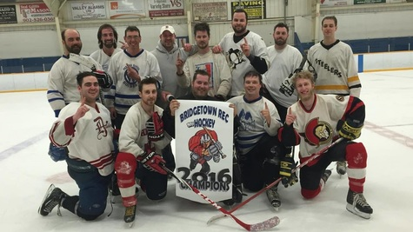

Presidents' Trophy
Awarded to the club finishing the regular season with the best overall record  2015-16-The Bridgetown Bandits - Finishing the season with a league best 11-3 record, 22 pts total.  2014-15- The Bridgetown Bandits - Finishing the season with a league best 11-2 record, 22pts total. | 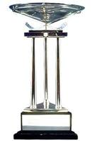

Art Ross Trophy
Awarded to the player who leads the league in total points at the end of the regular season.  2015-16- Adam Chipman (Bridgetown Bandits)- Amassing a BRHL league best 56 points in 14 games.  2014-15- Adam Chipman (Bridgetown Bandits)- Amassing a BRHL league best 38 points in 13 games ​ | 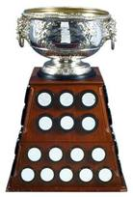

Rocket Richard Trophy
Awarded to the top goal scorer in the regular season  2015-16-Adam Chipman (Bridgetown Bandits)- Amassing a BRHL League best 31 Goals in 14 games  2014-15- Adam Chipman (Bridgetown Bandits)- Amassing a BRHL League best 23 Goals in 13 games | 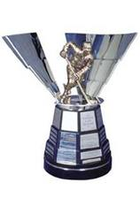

Crosby Trophy
Awarded to the top assist scorer in the regular season  2015-16-Adam Chipman (Bridgetown Bandits)- Amassing a BRHL League best 25 Assist in 14 games  2014-15- Jordan Saunder (Tooleys Pub)- Amassing a BRHL League best 16 Assist in 13 games | 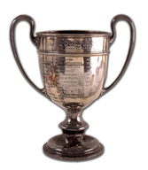

Vezina Trophy
Awarded to the league's top goaltender  2015-16- Corey Marcotte (Bridgetown Bandits) - Playing 14 games and finishing with a 11-3 record, Leader in Starts and 1 Shutout for best in the league  2014-15- Corey Marcotte (Bridgetown Bandits) - Playing 13 games and finishing with a 11-2 record & 3.00 GAA for best in the league | 